Spearman rank correlation: NZDUSD and USDJPY
Method 02 / daily log returns / Alpari D1 full available history

Study setup
Logical pair: NZDUSD , USDJPY
Broker symbols: NZDUSD_i , USDJPY_i
Snapshot: 2026-11-03_majors_alpari_D1
Timeframe: D1
Matched return window: 1999-01-05 to 2026-11-02 (UTC bar dates)
Matched return count n: 7185
Dropped unfinished last bar dated 2026-11-03 UTC after a tick-volume check against the prior complete day.
Complete matched rows (CSV): NZDUSD-USDJPY_Spearman_D1.csv
Complete matched rows (HTML table): NZDUSD-USDJPY_Spearman_D1_data.html

Method carried forward
Spearman rho is Pearson correlation on the ranks of matched daily log returns of close, ln(close_t / close_t-1), in the broker quote direction. Ties use average ranks. Quotes are not inverted. rho is symmetric under swap of the two symbols. rho = 0 means no consistent rank-order link in this sample; it does not mean no link of any kind. The score is not a cause, not a lead, and not a trading signal. Daily rows are not independent draws, so the two-sided p-value and approximate Fisher interval are reported and treated as secondary to rho. Same-sample Pearson r is shown only as a side check; a large rho minus r gap can flag outliers or a non-straight link.

Results
Spearman rho: -0.223115
Two-sided p-value: 9.52214e-82
Approximate 95% Fisher interval: [-0.244975, -0.201029]
Same-sample Pearson r: -0.133568
rho minus r: -0.089547

Conclusion
Over 7185 matched daily log-return rows for NZDUSD and USDJPY (broker quote directions unchanged), Spearman rho is -0.2231 (negative, weak rank-order association in this sample). Approximate 95% Fisher interval: [-0.2450, -0.2010]. Same-sample Pearson r is -0.1336 (rho minus r = -0.0895). Two-sided p under the usual independent-ranks model is 9.522e-82; that model does not match linked daily FX returns, so treat p as secondary. This does not establish cause, lead-lag, or a lasting trading rule.

Charts
Daily closes

Daily log returns
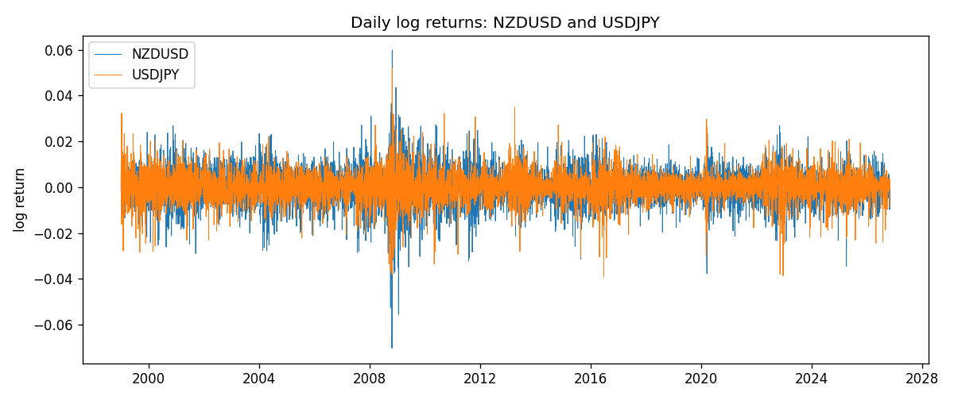
Log-return scatter
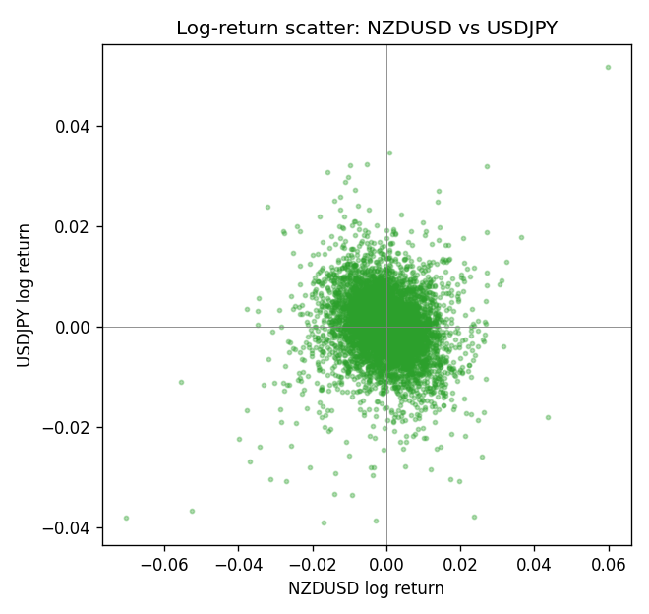
Rank-rank scatter
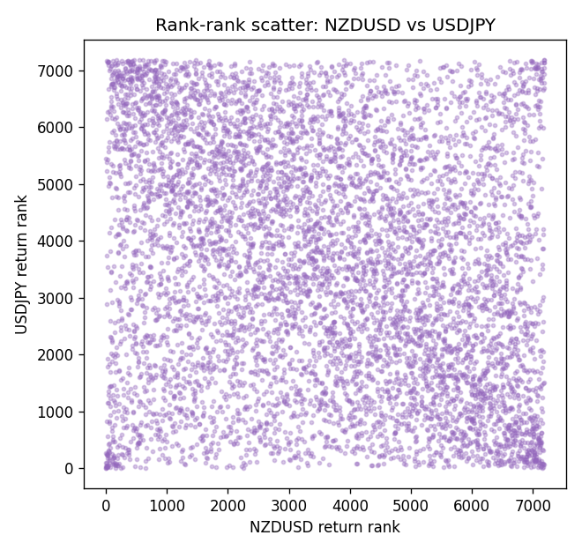

Data report
Every matched row that entered Spearman rho is stored in the sibling CSV named NZDUSD-USDJPY_Spearman_D1.csv. That file is the complete data archive for redrawing charts. Embedding all rows as a Word table is impractical at this length; the Word file holds the column list, column summaries, and the first and last 15 matched rows.
Columns: time, NZDUSD_open, USDJPY_open, NZDUSD_high, USDJPY_high, NZDUSD_low, USDJPY_low, NZDUSD_close, USDJPY_close, NZDUSD_tick_volume, USDJPY_tick_volume, NZDUSD_spread, USDJPY_spread, NZDUSD_real_volume, USDJPY_real_volume, NZDUSD_log_return, USDJPY_log_return
Column summaries (matched calculation rows)
column | count | mean | std | min | 25% | 50% | 75% | max
NZDUSD_open | 7185 | 0.65641035 | 0.10820414 | 0.3913 | 0.59133 | 0.6684 | 0.72491 | 0.88218
USDJPY_open | 7185 | 113.80829 | 19.224285 | 75.693 | 104.39 | 110.98 | 120.695 | 163.824
NZDUSD_high | 7185 | 0.6603272 | 0.1086977 | 0.3961 | 0.59474 | 0.672 | 0.72936 | 0.88421
USDJPY_high | 7185 | 114.30556 | 19.28576 | 76.001 | 104.868 | 111.439 | 121.26 | 163.978
NZDUSD_low | 7185 | 0.65272421 | 0.10779902 | 0.3897 | 0.58806 | 0.66417 | 0.72098 | 0.87988
USDJPY_low | 7185 | 113.28523 | 19.152023 | 75.402 | 103.88 | 110.53 | 120.17 | 163.628
NZDUSD_close | 7185 | 0.65648647 | 0.10820164 | 0.3907 | 0.59157 | 0.6684 | 0.72502 | 0.8822
USDJPY_close | 7185 | 113.8211 | 19.239467 | 75.811 | 104.38 | 111.015 | 120.69 | 163.851
NZDUSD_tick_volume | 7185 | 68717.699 | 123140.61 | 16 | 5585 | 33899 | 58511 | 1127682
USDJPY_tick_volume | 7185 | 106344.18 | 179438.14 | 149 | 9948 | 53202 | 92889 | 1803508
NZDUSD_spread | 7185 | 30.280167 | 25.649381 | 0 | 9 | 17 | 40 | 80
USDJPY_spread | 7185 | 20.273626 | 17.623751 | 0 | 6 | 11 | 30 | 50
NZDUSD_real_volume | 7185 | 1.6703703e+10 | 8.4983725e+10 | 0 | 0 | 0 | 0 | 2.705649e+12
USDJPY_real_volume | 7185 | 3.4781051e+10 | 1.6093614e+11 | 0 | 0 | 0 | 0 | 3.8834203e+12
NZDUSD_log_return | 7185 | 1.284e-05 | 0.0076404 | -0.07027433 | -0.00425236 | 0.00022967 | 0.00458145 | 0.05966839
USDJPY_log_return | 7185 | 4.789e-05 | 0.00620418 | -0.03908203 | -0.00320044 | 0.00011802 | 0.00340223 | 0.05184024
First 15 matched rows (selected columns)
time | NZDUSD_close | USDJPY_close | NZDUSD_log_return | USDJPY_log_return | NZDUSD_tick_volume | USDJPY_tick_volume
1999-01-05 | 0.5372 | 111.92 | -0.0018597736 | -0.00017868311 | 748 | 6367
1999-01-06 | 0.5383 | 112.77 | 0.0020455609 | 0.0075660159 | 823 | 6225
1999-01-07 | 0.5417 | 111.33 | 0.0062963171 | -0.012851583 | 878 | 6671
1999-01-08 | 0.5414 | 110.8 | -0.00055396548 | -0.0047719894 | 668 | 10700
1999-01-11 | 0.547 | 109.02 | 0.010290425 | -0.016195423 | 681 | 9168
1999-01-12 | 0.5441 | 112.6 | -0.0053157489 | 0.032310364 | 793 | 10131
1999-01-13 | 0.5387 | 113.52 | -0.0099742238 | 0.0081373171 | 1050 | 7265
1999-01-14 | 0.5386 | 113.52 | -0.00018564931 | 0 | 1137 | 6335
1999-01-15 | 0.5382 | 114.15 | -0.00074294208 | 0.0055343401 | 1124 | 5479
1999-01-18 | 0.5372 | 114.16 | -0.0018597736 | 8.7600193e-05 | 1022 | 5482
1999-01-19 | 0.5382 | 113.52 | 0.0018597736 | -0.0056219403 | 1389 | 5702
1999-01-20 | 0.5404 | 112.91 | 0.0040793678 | -0.0053879917 | 1678 | 5919
1999-01-21 | 0.5426 | 113.87 | 0.0040627941 | 0.0084664056 | 1599 | 6251
1999-01-22 | 0.5361 | 114.56 | -0.012051689 | 0.0060412564 | 1328 | 5453
1999-01-25 | 0.5342 | 113.72 | -0.0035504102 | -0.0073594164 | 1035 | 4696
Last 15 matched rows (selected columns)
time | NZDUSD_close | USDJPY_close | NZDUSD_log_return | USDJPY_log_return | NZDUSD_tick_volume | USDJPY_tick_volume
2026-10-13 | 0.56127 | 158.305 | 0.0047326165 | -0.0018932826 | 27958 | 81731
2026-10-14 | 0.55918 | 158.317 | -0.0037306483 | 7.5800166e-05 | 37319 | 95596
2026-10-15 | 0.56185 | 158.024 | 0.0047634855 | -0.0018524319 | 43714 | 115120
2026-10-16 | 0.56509 | 157.964 | 0.0057501001 | -0.00037976126 | 35806 | 86475
2026-10-19 | 0.56616 | 158.517 | 0.0018917133 | 0.0034946841 | 32069 | 70872
2026-10-20 | 0.56827 | 158.16 | 0.0037199341 | -0.0022546642 | 34470 | 82689
2026-10-21 | 0.57003 | 158.108 | 0.0030923331 | -0.00032883504 | 30020 | 67431
2026-10-22 | 0.56815 | 156.755 | -0.0033035227 | -0.0085942669 | 39159 | 100312
2026-10-23 | 0.56991 | 156.81 | 0.0030929853 | 0.00035080446 | 33693 | 103374
2026-10-26 | 0.56826 | 157.458 | -0.0028993932 | 0.0041238746 | 30716 | 87120
2026-10-27 | 0.56811 | 157.894 | -0.00026399852 | 0.0027651658 | 32660 | 72962
2026-10-28 | 0.56261 | 157.743 | -0.0097283914 | -0.00095679538 | 42740 | 72076
2026-10-29 | 0.56296 | 157.683 | 0.00062190714 | -0.00038043789 | 40247 | 88229
2026-10-30 | 0.56307 | 157.516 | 0.00019537668 | -0.0010596481 | 39305 | 106706
2026-11-02 | 0.56161 | 157.933 | -0.0025962955 | 0.0026438521 | 35347 | 80702

